GGN - Geopark Annual Report 2020

1. GEOPARK IDENTITY
Geopark name, country, regional Network:
Zhangjiajie UNESCO Global Geopark, P. R. China, APGN
Year of inscription / Year of the last revalidation: 2004/2018
Representative photo with caption (from the most important event this year)
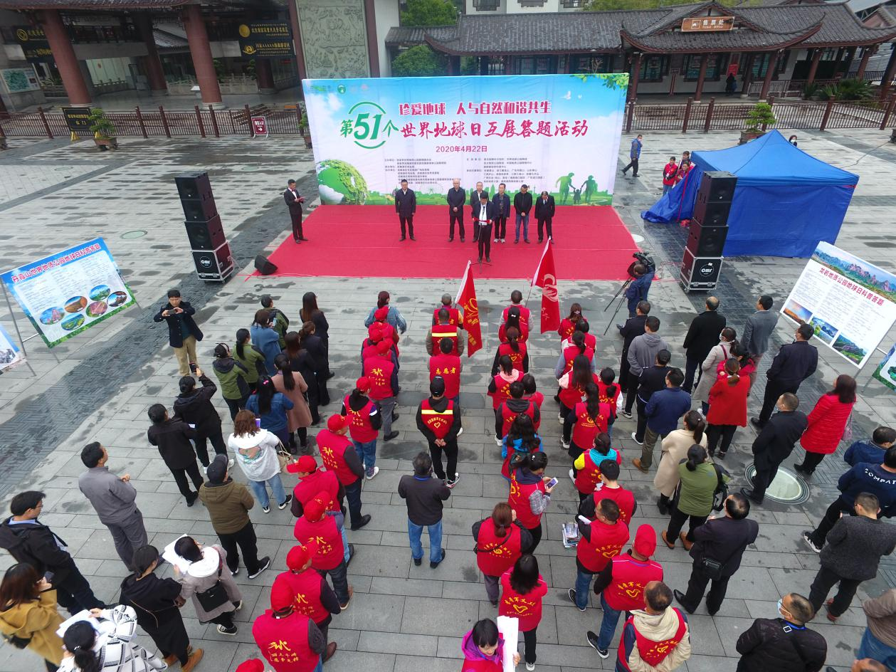
Representative of important activities of Zhangjiajie UGGp in 2020: Celebrations of Earth Day and the 1st APGN Geopark Week (April 22 to 28, 2020) with displays of 11 sister geoparks in Zhangjiajie UGGp

2. GEOPARK FIGURES
Number of Geopark staffs: 883 staffs
Number of visitors: 14.7 million person times
Number of Geopark events: 40
1. In January, a new ticketing system at major scenic areas in Zhangjiajie UGGp took effect officially, marking the realization of ticket-purchasing with real names, face-screening and more new functions in the areas;
2. In January, activities of voluntarily diagnosing, distributing introduction materials on science-technology and policies were made to the public at Zhangjiajie UGGp, aiming at promoting civilized practices in the new era so as to make all people happy;
3. In January, more than 800 migrants from the scenic areas in Zhangjiajie UGGp to new residential areas gathered together and celebrated the coming of a new year, with various forms of performance;
4. In Feb., more than 5000 voluntaries participated in the prevention and control of the spreading of Covid-19 in Zhangjiajie UGGp;
5. In Feb., wide distribution was carried out in Zhangjiajie UGGp of the letter from GGN Executive Board who expressed solidarity to Chinese Global Geoparks fighting against the spread of Covid-19;
6. In March, all scenic areas and the transport inside in Zhangjiajie City, including in Zhangjiajie UGGp, were made freely accessible until Dec. 31, 2020 for medical staffs from all over the country;
7. In March, a lot of new trees were planted in Zhangjiajie UGGp to celebrate National Tree-Planting Day (March 12);
8. In March, online sellings of local products, including Brocades of Tujia Nationality, Power of Kudzu Vine Roots, Tribute Rice and more were made in Zhangjiajie UGGp;
9. In March, tourism experts of Zhangjiajie City walked into the scenic areas of Zhangjiajie UGGp, conducting living broadcast of tourism resources themed with Zhangjiajie Landscape and the international importance;
10. In April, celebrations of Earth Day and 1st APGN Geopark Week (April 22 to 28) with the displays of sister geoparks were carried out at Zhangjiajie UGGp;
11. In April, 25th World Book and Copyright Day was launched in Zhangjiajie UGGp, encouraging all people to enhance knowledge through reading books;
12. In June, the thematic activities of 2020 National Cultural and Nature Heritage Day and 2nd Hunan Cultural and Nature Heritage Day were held at Zhangjiajie UGGp;
13. In July, the program of “Science-popularization, research and learning through touring” was launched in Zhangjiajie UGGp, with the participation of children under 14 years old for free and of their parents at a half price;
14. In July, a meeting was held with travel agencies in Zhangjiajie UGGp on how to effectively carry out the program of “Science-popularization, research and learning through touring”;
15. In July, a special model on the voluntary service of Communist Party members took effect in Zhangjiajie UGGp, aiming at speeding up tourism recovery;
16. In July, lecturers and students from School of Geosciences and Info-physics at Central South University of China carried out geological practices in Zhangjiajie UGGp, with videos being recorded;
17. In July, managing staff of Zhangjiajie UGGp participated in the training activities for science-popularization volunteers organized by Danxiashan UGGp;
18. In July, Zhangjiajie UGGp participated in the Welcome Digital Event co-organized by UNESCO and the Global Geopark Network on July 16 to celebrate the nomination of 16 New UNESCO Global Geoparks and sent congratulations to sister geopark Xiangxi UGGp;
19. In August, trainings were made at Zhangjiajie UGGp on how to sell agricultural products in MGTV’s Poverty Alleviation Cloud Supermarket;
20. In August, a special training was conducted at Zhangjiajie UGGp for supervisors of the program of “Science-popularization, research and learning through touring”, focusing on world natural heritage and global geopark;
21. On August 19, a large public event was held at Zhangjiajie UGGp with the participation of around 100 City TV stations across the country to show respect to national heroes fighting against Covid-19;
22. In August, 2020 Hong Kong Photographs Display was held at Zhangjiajie UGGp, with more than 120 photos in 7 themes on show;
23. In August, managing staffs of Enshi Tenglong Grand Gorge Geopark visited Zhangjiajie UGGp and communicated managing experiences with the managing staffs of Zhangjiajie UGGp;
24. In August, classes on intangible cultural heritage were presented at Zhangjiajie UGGp such that school summer holiday had more abundant activities;
25. In Sept., activities themed with Clean Plate Campaign were carried out in primary and high schools in Zhangjiajie UGGp.
26. In Sept., Funiushan UGGp of China visited Zhangjiajie UGGp, communicated managing experiences, and established sister geoparks relationship;
27. In Oct., a program of Cherishing and Protecting Rivers was launched at Zhangjiajie UGGp;
28. In Oct., the managing staffs of Zhangjiajie UGGp attended 2020 UNESCO Global Geoparks Annual Meeting of China at Guangwushan-Nuoshuihe UGGp, Sichuan, China;
29. In Oct., the managing staffs of Zhangjiajie UGGp attended 2020 Ningde UGGp Workshop at Fuan City, Fujian, China;
30. In Oct., Leye-Fenshan UGGp of China, a sister geopark of Zhangjiajie UGGp, visited Zhangjiajie UGGp and communicated managing experiences;
31. In Oct., activities on “Protecting School Students 2020 - Allowing Healthy Books into Schools” were launched in Zhangjiajie UGGp;
32. In Oct., the ticketing system in Zhangjiajie UGGp was enhanced in quality, aiming at promoting tourism services during the periods of double holidays;
33. Zhangjiajie UGGp participate in the online APGN CC Meeting on 20 October;
34. In Nov., a meeting between Zhangjiajie UGGp and Hunan Normal University was made to discuss the potential for co-establishing a practical base for geosciences popularization;
35. In Nov., an international dialogue between Zhangjiajie UGGp and the Dolomite Mountains in Italy, World Natural Heritage Site and UGGp, was held in the Geological Museum of Zhangjiajie City;
36. In Nov., Alex UGGp of China, a sister geopark of Zhangjiajie UGGp, visited Zhangjiajie UGGp and communicated managing experiences;
37. In Nov., 2020 outdoor keep-fit and recreation conference of China and the contest of high-altitude sling at Huangshizhai were held at Zhangjiajie UGGp;
38. In Nov., Zhangjiajie UGGp participated in the 1st GGN Digital Forum 2020 (Nov. 17 and 18);
39. In Dec., landscape paintings of the scenic sites in Zhangjiajie UGGp were presented during the display of the art works of national new art group in Beijing Yanhuang Art Museum;
40. In Dec., more than 5000 outdoor enthusiasts climbed Huangshizhai (a key scenic area in Zhangjiajie UGGp) on foot to welcome the coming of a new year.

Number of school classes realizing Geopark educational programs:
20 indoor classes were given in the environmental education and science popularization bases set up by Zhangjiajie UGGp respectively in Minzu Middle School and Suoxiyu Complete Primary School; 6 classes on science popularization of Zhangjiajie Landscape were given to students from the other primary and high schools in Zhangjiajie UGGp and from School of Geosciences and Info-physics at Central South University of China.

Number of Geopark press release: 36 in Chinese

3. GEOPARK ACTIVITIES
Major achievements in 2020
- In Feb., Zhangjiajie UGGp organized more than 5000 voluntaries in the prevention and control of the spreading of Covid-19;
- In March, Zhangjiajie UGGp made all scenic areas and the transport inside freely accessible until Dec. 31, 2020 for medical staffs from all over the country;
- In March, Zhangjiajie UGGp organized online selling of local products, including Brocades of Tujia Nationality, Power of Kudzu Vine Roots, Tribute Rice and more;
- In April, celebrations of Earth Day and 1st APGN Geopark Week (April 22 to 28) with the displays of sister geoparks were organized by Zhangjiajie UGGp;
- In June, Zhangjiajie UGGp hosted the thematic activities of 2020 National Cultural and Nature Heritage Day and 2nd Hunan Cultural and Nature Heritage Day;
- In July, the program of “Science-popularization, research and learning through touring” was launched in Zhangjiajie UGGp, with the participation of children under 14 years old for free and of their parents at a half price;
- In Sept., Zhangjiajie UGGp established a sister geoparks relationship with Funiushan UGGp of China.
- In July, lecturers and students from School of Geosciences and Info-physics at Central South University of China carried out geological practices in Zhangjiajie UGGp, with videos being recorded;
- In August, trainings were made at Zhangjiajie UGGp on how to sell products in MGTV’s Poverty Alleviation Cloud Supermarket;
- On August 19, a large public event was held at Zhangjiajie UGGp with the participation of around 100 City TV stations across the country to show respect to national heroes fighting against Covid-19;
- In August, a special training was conducted at Zhangjiajie UGGp for supervisors of the program of “Science-popularization, research and learning through touring”, focusing on world natural heritage and global geopark;
- In Nov., Zhangjiajie UGGp hosted 2020 outdoor keep-fit and recreation conference of China and the contest of high-altitude sling at Huangshizhai, a main scenic area in Zhangjiajie UGGp.
Contribution towards GGN - Networking and participation
- In April, celebrations of Earth Day and 1st APGN Geopark Week (April 22 to 28) with the displays of 10 sister geoparks were organized by Zhangjiajie UGGp;
- In July, managing staff of Zhangjiajie UGGp participated in the training activities for science-popularization volunteers organized by Danxiashan UGGp of China;
- On July 16, Zhangjiajie UGGp participated in the Welcome Digital Event co-organized by UNESCO and the Global Geopark Network to celebrate the nomination of 16 New UNESCO Global Geoparks and sent congratulations to sister geopark Xiangxi UGGp;
- In August, Zhangjiajie UGGp hosted the visit of the managing staffs of Enshi Tenglong Grand Gorge Geopark from Hubei Province of China and introduced the development of Zhangjiajie UGGp and GGN;
- In Sept., Zhangjiajie UGGp hosted the visit of the managing staffs of Funiushan UGGp of China and established a sister geoparks relationship;
- In Oct., the managing staffs of Zhangjiajie UGGp attended 2020 UNESCO Global Geoparks Annual Meeting of China at Guangwushan-Nuoshuihe UGGp, Sichuan, China;
- In Oct., the managing staffs of Zhangjiajie UGGp attended 2020 Ningde UGGp Workshop at Fuan City, Fujian, China;
- In Oct., Leye-Fenshan UGGp of China, a sister geopark of Zhangjiajie UGGp, visited Zhangjiajie UGGp and communicated managing experiences;
- On 20 October, Zhangjiajie UGGp participate in the online APGN CC Meeting;
- In Nov., an international dialogue between Zhangjiajie UGGp and the Dolomite Mountains in Italy, World Natural Heritage Site and UGGp, was held in the Geological Museum of Zhangjiajie City;
- In Nov., Zhangjiajie UGGp hosted the visit of the managing staffs of Alex UGGp of China, a sister geopark of Zhangjiajie UGGp, and communicated managing experiences;
- In Nov., Zhangjiajie UGGp participated in the 1st GGN Digital Forum 2020 (Nov. 17 and 18).
Management and Financial Status
The administrative committee of Zhangjiajie UGGp has been actively undertaking all routine management duties of Zhangjiajie UGGp.
Financial Status: Zhangajiajie UGGp has an independent annual financial budget approved by the government of Wulingyuan District and in 2020, the financial status maintained as what was approved in early time of the year.
Geoconservation
- According to “Plan for geoconservation in Zhangjiajie UGGp (2011-2020)” and “Plan of Zhangjiajie National Geopark”, geoheritages Zhangjaijie UGGp, frequent field investigations were conducted to make sure that all geoheritages in Zhangjiajie UGGp are conserved according to the level of conservation in the different areas of the geopark.
- Themed science popularization and propaganda activities for promoting geoconservation in Zhangjiajie UGGp were conducted opening to the public on World Earth Day, APGN Geopark Week, and the other events.
- The database on the geoheritage sites in Zhangjiajie UGGp was updated and expanded.
- An evaluation was given to the project “Natural hazards prevention research and applications”.
- All of the illegal quarry sites in Zhangjiajie UGGp were banned and closed.
- Conducting forest protection and fire prevention, monitoring and patrol, and more activities closely with the surrounding communities to ensure that the rights and benefits of the residents in Zhangjiajie UGGp are maintained.
Sustainable tourism (Geotourism)
Aiming to achieve sustainable tourism, Zhangjiajie UGGp conducted a large number of activities in 2020, mainly including:
(1) upgrading and cleaning public toilets, walking paths, road signs, and science popularization display boards;
(2) enhancing wireless network and intelligent video monitoring system;
(3) providing bicycles and environmentally friendly sightseeing electric vehicles for tourists;
(4) updating introduction materials and the website of the geopark from time to time so as to to provide detailed information on the latest activities taking place in the geopark;
(5) providing guide manuals for tourists with detailed traffic information within the geopark and nearby;
(6) inviting professionals with geological knowledge to lead scientific tour guides in Chinese and/or English for special groups of visitors who are interested in the geology and geomorphology of the geopark.

New education programs on geoconservation, sustainable development and disaster risk reduction
In 2020, Zhangjiajie UGGp organized specialized science popularization and environmental education activities with primary and middle schools during school breaks, such as summer camping, and internationally important days, typically on “World Earth Day”, APGN Geopark Week, “National Natural and Cultural Heritage Day”, “National Tree-planting Day” and more. Furthermore, Zhangjiajie UGGp provided lecture notes on geoscience popularization for primary and middle school students for schools with science popularization bases to teach in their science classes. Moreover, Zhangjiajie UGGp helped many universities to provide practical classes, such as Central South University of China. Importantly, Zhangjiajie UGGp also helped Wulingyuan Tourism Vacational School to offer geosciences classes, 20 hours in the school term.
Strategic partnerships
Zhangjiajie UGGp has developed and maintained partnerships with many universities, research organizations and local enterprises, and in 2020, a lot of activities were carried out by them in collaboration with Zhangjiajie UGGp, including the Institute of Geographic Sciences and Natural Resources Research of Chinese Academy of Sciences, University of Chinese Academy of Sciences, Beijing University, Tongji University, Central South University, Jishou University, Wulingyuan Tourism Vacational School, Minzu Middle School of Zhangjiajie City, Geological Environment Monitoring Master Station of Huanan Province, Geological Museum of Hunan Province, Zhangjiajie City Museum, Hunan Academy of Geological Sciences, Xiang-A-Mei Food Company, Guai-Yao-Mei Tujia Brocade Company, Wulingyuan Exhibition Center of Junsheng Shashi (rock sands) Paintings, etc.
Promotional activities
- In Jan., the governing body of Zhangjiajie UGGp provided financial support of 58,000 Yuan to travel agencies to promote tourism in Zhangjiajie UGGp;
- In March, Zhangjiajie UGGp made all scenic areas and the transport inside freely accessible until Dec. 31, 2020 for medical staffs from all over the country;
- In March, Zhangjiajie UGGp organized online selling of local products, including Brocades of Tujia Nationality, Power of Kudzu Vine Roots, Tribute Rice and more;
- During celebrations of Earth Day and 1st APGN Geopark Week (April 22 to 28) , introductions and displays of Zhangjiajie UGGp were made online and in the other 9 sister geoparks;
- In late June, Zhangjiajie UGGp hosted the thematic activities of 2020 National Cultural and Nature Heritage Day and 2nd Hunan Cultural and Nature Heritage Day, with a focus to promote Zhangjiajie UGGp and Natural Heritage;
- In July, the program of “Science-popularization, research and learning through touring” was launched in Zhangjiajie UGGp, with the participation of children under 14 years old for free and of their parents at a half price;
- In August, trainings were made on how to sell products in MGTV’s Poverty Alleviation Cloud Supermarket, with Zhangjiajie UGGp as an example;
- On August 19, a large public event was held at Zhangjiajie UGGp with the participation of around 100 City TV stations across the country to show respect to national heroes fighting against Covid-19;
- In Sept., Zhangjiajie UGGp established a sister geoparks relationship with Funiushan UGGp of China;
- In Dec., landscape paintings of the scenic sites in Zhangjiajie UGGp were presented during the display of the art works of national new art group in Beijing Yanhuang Art Museum;
- In Nov., Zhangjiajie UGGp hosted 2020 outdoor keep-fit and recreation conference of China and the contest of high-altitude sling at Huangshizhai, a main scenic area in Zhangjiajie UGGp.

4. CONTACTS
Administrative Officer of Zhangjiajie UGGp:
Ms Zhou Yihen, Email: 349071923@qq.com
Scientific Responsible (Geosciences) of Zhangjiajie UGGp:
Prof. Huang He-qing, Email: huanghq@igsnrr.ac.cn

