Geopark Annual Report 2019 of Keketuohai UNESCO Global Geopark

1. GEOPARK IDENTITY
Geopark name, country, regional network: Keketuohai UNESCO Global Geopark (China, Asia Pacific Geoparks Network)
加入年份/上次再评估年份：2017年/2020年待评估
Year of inscription /Year of the last revalidation: 2017/yet to be revalidation in 2020
代表性照片：
Representative Photo:
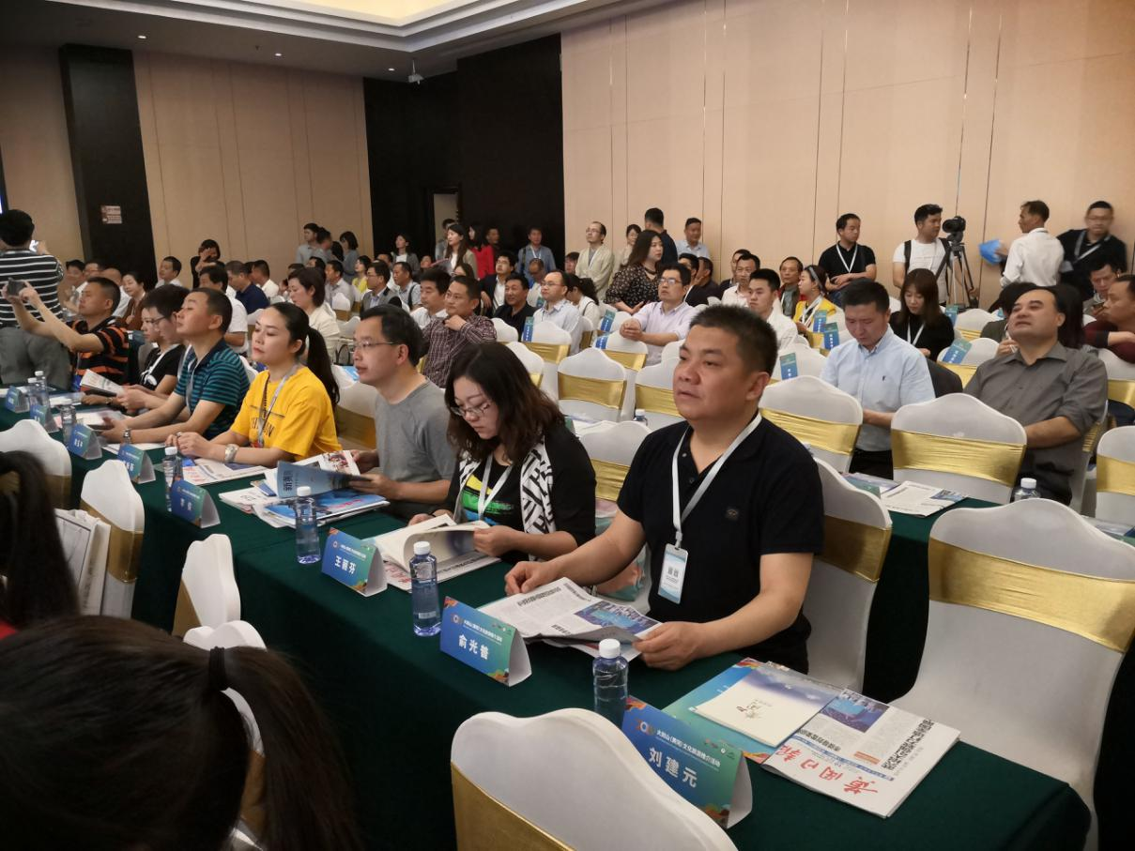
2019年5月参加黄冈—大别山世界地质公园揭碑开园活动
The attendance to the opening activity of Huanggang Dabieshan UNESCO Global Geopark in May 2019

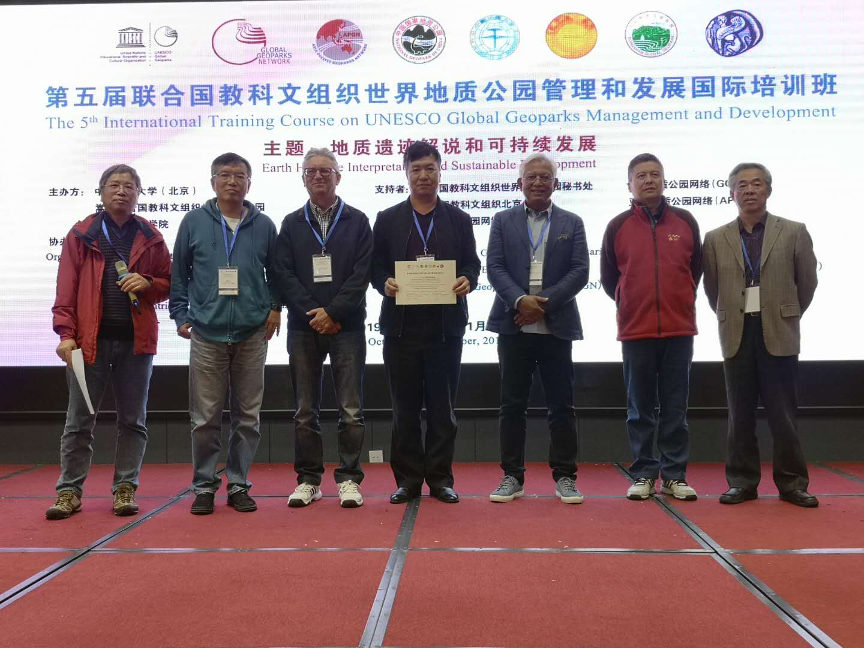
2019年10月31日参加第五届联合国教科文组织世界地质公园管理和发展国际培训班
The attendance to the 5th International Training Course on UNESCO Global Geoparks Management and Development on October 31, 2019
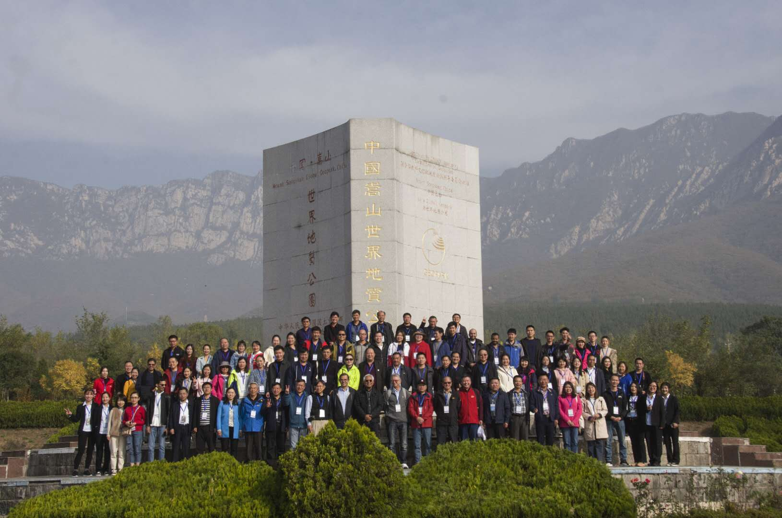
2019年11月2日与嵩山世界地质公园考察交流学习
Visit Songshan UNESCO Global Geopark on November 2, 2019 for exchange learning
2.地质公园数据
2. GEOPARK FIGURES
员工人数：公园共有458名员工，其中包含地质学家5位。
Number of Geopark staffs: The geopark has 458 employees, including 5 geologists.
游客人数：620.9万人次，同比增长42.24%。
Number of Visitors: 6,209,000 visits from tourists, a year-on-year growth of 42.24%.
活动次数：2019年度举办活动6次。举办2019年1月24日，中泰教育冬令营首批可可托海世界地质公园研学团20名，到可可托海世界地质公园地质陈列馆、三号矿景区开展科普教育活动；2019年5月26日，阿勒泰元创旅游有限公司组织的乌鲁木齐市第91小学的研学团队30余人，到可可托海世界地质公园地质陈列馆、三号矿景区等开展科普教育活动；2019年11月，在第十四届新疆冬季旅游产业交易博览会进行专题展览；2019年11月，在地质公园三号院举行顾智勇油画作品专题展览；2019年10月及12月，公园邀请中国地质科学院专家苏德辰教授开展《地质之美与丹霞地貌》科普讲座；2019年4月，富蕴县举办“昊蕴杯”赛马比赛，展示丰富的民俗体验及多姿多彩的民俗风情；2019年8月，富蕴县举办“传承可可托海精神·富蕴秋季赛马活动”，此次比赛还增设了姑娘追、马上拾银、马上射箭、押加比赛、摔跤比赛、扳手腕比赛等丰富多彩的民俗项目赛事。
Number of Geopark events: 6 activities were held in 2019. On January 24, 2019, the first study group of 20 students from the Keketuohai UNESCO Global Geopark of Zhongtai Education Winter Camp carried out science popularization and education activities in the Geological Exhibition Hall and No. 3 Mine of the geopark. On May 26, 2019, a study group of more than 30 students from Urumqi No.91 Primary School organized by Altay Yuanchuang Tourism Co., Ltd. carried out science popularization and education activities in the Geological Exhibition Hall and No. 3 Mine of the geopark. In November 2019, a theme exhibition was carried out at the 14th Xinjiang Winter Tourism Trade Fair. In November 2019, the Special Exhibition of Gu Zhiyong's Oil Paintings was held at No. 3 Courtyard of geopark; In October and December 2019, the park invited Professor Su Dechen, an expert of Chinese Academy of Geological Sciences, to give a scientific lecture Geological Beauty and Danxia Landform. In April 2019, Fuyun County held the "Haoyun Cup" horse racing competition, displaying rich folk experiences and diversified folk customs. In August 2019, Fuyun County held the "Inheritance of Keketuohai Spirit · Fuyun Autumn Horse Racing Activity"; a variety of folk events such as girls chasing, silver collecting on the horse's back, archery on the horse's back, tug-of-war competition, wrestling competition and wrist wrestling competition were added into the activity.
开展地质公园教育计划的学校班级数：2个
Number school classes realize Geopark educational programmes: 2
地质公园发表新闻稿数量：1篇
Number of Geopark press release: 1
3.地质公园活动：2019年5月，公园参加敦煌世界地质公园揭碑开园活动并参加考察，充分参观考察了敦煌世界地质公园的建设发展情况，并与参会公园交流经验；
GEOPARK ACTIVITIES: In May 2019, Keketuohai Geopark attended the opening activities of Dunhuang UNESCO Global Geopark, inspected its construction and development and exchanged experience with other geoparks;
2019年5月，公园参加黄冈-大别山世界地质公园揭碑开园活动并参加考察，充分考察了黄冈-大别山世界地质公园建设发展情况，并与参会公园交流经验；
In May 2019, Keketuohai Geopark attended the opening activities of Huanggang Dabieshan UNESCO Global Geopark, inspected its construction and development and exchanged experience with other geoparks;
2019年6月，公园参加丹霞山世界地质公园交流会并参加考察，进一步学习了丹霞山世界地质公园科学普及活动组织经验；
In June 2019, Keketuohai Geopark attended the symposium of Danxiashan UNESCO Global Geopark and participated in an investigation. It also further learned the organization experience of science popularization activities of Danxiashan UNESCO Global Geopark;
2019年7月，阿拉善沙漠世界地质公园到可可托海世界地质公园考察，学习交流了世界地质公园管理、建设及旅游推广经验；
In July 2019, Alxa Desert UNESCO Global Geopark visited Keketuohai Geopark, learned and exchanged the experience of geopark construction and management as well as tourism promotion;
2019年7月，公园访问张家界世界地质公园，学习交流了世界地质公园管理、建设及旅游推广经验；
In July 2019, Keketuohai Geopark visited Zhangjiajie UNESCO Global Geopark and learned and exchanged the experience of geopark construction and management as well as tourism promotion;
2019年10月，公园参加敦煌世界地质举办的年会并参加考察，充分参观考察了敦煌世界地质公园的建设发展情况，并与参会公园交流经验；
In October 2019, Keketuohai Geopark attended the annual conference of Dunhuang UNESCO Global Geopark, inspected its construction and development and exchanged experience with other parks;
2019年10月，公园到嵩山世界地质公园考察交流，学习交流了世界地质公园世界地质公园地质环境保护、旅游与环境协调发展的相关问题。
In October 2019, Keketuohai Geopark visited Songshan UNESCO Global Geopark and the two sides exchanged views on problems related to environmental protection and harmonious development between tourism and environment;
2019年主要成就：
Major achievements in 2019:
1.编制了《2020年可可托海世界地质公园再评估系列材料》
1. Compiling A Series of Materials for the Reassessment of the Keketuohai UNESCO Global Geopark in 2020;
2.2019年，地质公园被共青团新疆维吾尔自治区委员会授予为新疆共青团干部培训教学基地；
2. In 2019, the geopark was awarded as the training and teaching base for Xinjiang Communist Youth League officials by the Xinjiang Uygur Autonomous Region Committee of the Communist Youth League;
3.2019年，地质公园被自治区科学技术协会授予为自治区科普教学基地。
3. In 2019, the geopark was awarded as the science popularization teaching base of the autonomous region by the Xinjiang Association for Science and Technology.
4.2019年，地质公园被自治区社会科学界联合会授予为自治区社会科学普及基地；
4. In 2019, the geopark was awarded as the Social Sciences Popularization Base of Xinjiang Uygur Autonomous Region by the Federation of Social Science Associations of Xinjiang Uygur Autonomous Region;
5.2019年，地质公园被文化和旅游厅、生态环境厅授予为自治区生态旅游示范区。
5. In 2019, the geopark was awarded as the Ecological Tourism Demonstration Zone of Xinjiang Uygur Autonomous Region by the Department of Culture and Tourism and the Department of Ecology and Environment of Xinjiang Uygur Autonomous Region.
6.投资2.73亿元，为公园内矿山环境治理与植被修复、水环境保护治理、人居环境综合整治三大类进行了综合治理。
6. The geopark has invested RMB 273 million in the comprehensive treatment in three aspects in the geopark, namely the mine environment governance & vegetation restoration, water environment protection & treatment, and comprehensive improvement of the living environment.
对GGN的贡献——网络活动和参与：
Contribution towards GGN - Networking and Participation:
1.2019年第五届联合国教科文组织世界地质公园国际培训班；
1. Attend The 5th International Training Course on UNESCO Global Geoparks Management and Development
2.2019年中国世界地质公园大会；
2. Attend China International Conference on UNESCO Global Geoparks 2019;
3.2019年5月，公园参加敦煌世界地质公园揭碑开园活动并参加考察；
2. In May 2019, the geopark participated in the opening activities of Dunhuang UNESCO Global Geopark and the investigation;
4.2019年5月，公园参加黄冈-大别山世界地质公园揭碑开园活动并参加考察；
4. In May 2019, the geopark participated in the opening activities of Huanggang Dabieshan UNESCO Global Geopark and the investigation;
5.2019年6月，公园参加丹霞山世界地质公园交流会并参加考察；
5. In June 2019, the geopark participated in the Exchange Meeting of Danxiashan UNESCO Global Geopark and the investigation;
6.2019年7月，阿拉善沙漠世界地质公园到可可托海世界地质公园考察；
6. In July 2019, Alxa Desert UNESCO Global Geopark visited Keketuohai UNESCO Global Geopark;
7.2019年7月，公园访问张家界世界地质公园；
7. In July 2019, the geopark visited Zhangjiajie UNESCO Global Geopark;
8.2019年10月，公园参加敦煌世界地质举办的年会并参加考察；
8. In October 2019, the geopark attended the annual meeting of Dunhuang UNESCO Global Geopark and the investigation;
9.2019年10月，公园到嵩山世界地质公园考察交流。
9. In October 2019, the geopark visited Songshan UNESCO Global Geopark for an investigation and exchange.
管理和财务状况：可可托海世界地质公园始终遵循“保护第一、科学规划、合理开发、永续利用”的指导思想，坚持把公园建设同经济社会发展、带动牧民增收结合起来，把公园开发利用同地质研究、地学科普结合起来，坚持在保护中开发、在开发中保护，对公园内的地质遗迹进行了专门的系统保护，促进了公园的持续健康有序发展。财务状况良好，完成旅游收入70.19亿元，同比增长42.7%。
Management and Financial status: Following the guiding philosophy of "Prior Protection, Scientific Planning, Rational Development, and Sustainable Utilization", Keketuohai UNESCO Global Geopark has persisted in combining the geopark construction with the socio-economic development and the income increase of herdsmen, as well as combining the geopark development and utilization with geological research and geoscience popularization. Meanwhile, Keketuohai UNESCO Global Geopark has placed equal emphasis on the geopark protection and development by carrying out special systematic protection to the geological relics within the geopark to facilitate its sustainable, healthy and orderly development. The financial situation is good. The geopark's tourist income has reached RMB 7,019 million, a year-on-year increase of 42.7%.
地质遗迹保护：一是着手是完善提升可可托海世界地质公园宣传材料；二是完善提升可可托海世界地质公园专题片、画册，去年已完成专题片的补充采集工作，现正在进行剪辑；三是编制发布《可可托海世界地质公园地质遗迹保护管理办法》；四是编制发布《可可托海世界地质公园防灾减灾方案 》；五是制定发布《可可托海世界地质公园地质材料售卖条例》；六是建立建设可可托海世界地质公园防灾减灾方案及标识系统；七是建立可可托海世界地质公园合作伙伴网络，加强可可托海世界地质公园产品建设；八是完善可可托海世界地质公园专家网络；九是完善提升可可托海世界地质公园网站、APP及其他传媒系统；十是增强可可托海世界地质公园与其他公园、科研团队等的合作及交流；十一是增加可可托海世界地质公园女性领导岗位。
Geoconservation: First, updating the promotional materials of Keketuohai UNESCO Global Geopark; second, improving the TV special and picture album of the geopark, among which the TV special was supplemented last year and is being edited currently; third, preparing and issuing the Measures for Protection and Management of Geological Relics of Keketuohai UNESCO Global Geopark; fourth, preparing and issuing the Plan for Disaster Prevention and Mitigation of Keketuohai UNESCO Global Geopark; fifth, formulating and issuing the Regulations on Sale of Geological Materials of Keketuohai UNESCO Global Geopark; sixth, making plans and establishing a sign system for disaster prevention and mitigation of the geopark; seventh, forming a partner network and enhancing the product construction of the geopark; eighth, upgrading the expert network of the geopark; ninth, upgrading the website, APP and other media systems of the geopark; tenth, enhancing the cooperation and exchanges of Keketuohai UNESCO Global Geopark with other geoparks and scientific research teams; eleventh, increasing the number of female leaders of the geopark.
可持续旅游（地学旅游）：全年共接待游客620.9万人次，完成旅游收入70.19亿元，旅游人数同比增长了42.7%。地质公园形象不断提升。
Sustainable tourism (geotourism): A total of 6.209 million visits were received in the whole year, an increase of 42.7% over the same period last year, with a tourism income of RMB 7.019 billion. The image of the geopark has been continually improved.
有关地质遗迹保护、可持续发展和减少灾害风险的新教育计划：
New Education programmes on geoconservation, sustainable development and disaster risk reduction:
1.编制《可可托海世界地质公园地质遗迹保护管理办法》、《可可托海世界地质公园防灾减灾方案》、《可可托海世界地质公园地质材料售卖条例》；
1. The files of Measures for Protection and Management of Geological Relics of Keketuohai UNESCO Global Geopark, Plan for Disaster Prevention and Mitigation of Keketuohai UNESCO Global Geopark and Regulations on Sale of Geological Materials of Keketuohai UNESCO Global Geopark were compiled;
2.持续开展“4.22世界地球日、5.12防震减灾日、6.5环境日、6.25土地日、全国科普日”等科普活动；
2. The scientific knowledge popularization activities related to the World Earth Day on April 22, National Disaster Prevention and Mitigation Day on May 12, World Environment Day on June 5, National Land Day on June 25, and National Science Popularization Day were conducted in succession.
3.筹建可可托海国脉传承研学基地；
3. Preparations were made for the establishment of a Keketuohai research base for the inheritance of the national lifeblood.
4.打造地质遗迹科普教育基地。
4. A base for geological relics knowledge popularization was established.
战略合作伙伴：与中国新疆维吾尔自治区地质矿产研究所合作开展公园科研项目并签订合作协议。
Strategic Partnership: Cooperated with Xinjiang Institute of Geology and Mineral Resources to implement the scientific research project for the geopark and sign the cooperation agreement.
宣传推广活动：利用网络、微信、旅游推介会等平台，和“泰旅集团”、远方旅游公司、北疆明珠公司合作加大旅游品牌打造力度，围绕“爱国、忠诚、奉献”的可可托海精神、独特的自然地质奇观、丰富的冰雪资源，全面打响“可可托海红色文化”“可可托海世界地质公园”“冬季冰雪旅游”旅游品牌，全面提升知名度和影响力。
Activities of publicity and promotion: we cooperated with Xinjiang Altay Tourism Group, Xinjiang Yuanfang Travel Co., Ltd. and Xinjiang Keketuohai Beijiang Mingzhu Tourism Development Co., Ltd. to further build tourism brands with a greater effort via the platforms provided by the Internet, WeChat and travel promotion conferences. With the Keketuohai spirit of "patriotism, loyalty and dedication" and relying on unique natural geological landscapes and rich ice & snow resources, we successfully created such tourism brands as "Keketuohai Red Culture" and "Keketuohai UNESCO Global Geopark" and made them well known, enhancing the popularity and influence of Keketuohai in an all-round way.
4. 联系人
4. Contacts
管理者：孙晓进，xjfykkthgwh@sina.com
Manager: Sun Xiaojin, xjfykkthgwh@sina.com
科学负责人（地质学家）：彭东，13518166830@139.com
Scientific Responsible (Geologist): Peng Dong, 13518166830@139.com

新疆富蕴可可托海地质公园管理委员会
Management Committee of Xinjiang Fuyun Keketuohai Geopark
2020年4月27日
April 27, 2020

