GGN - Geopark Annual Report 2018

1. GEOPARK IDENTITY
Geopark name, country, regional Network: Longhushan UNESCO Global Geopark (China, Asia Pacific Geopark Network)
Year of inscription / Year of the last revalidation: 2007/2018
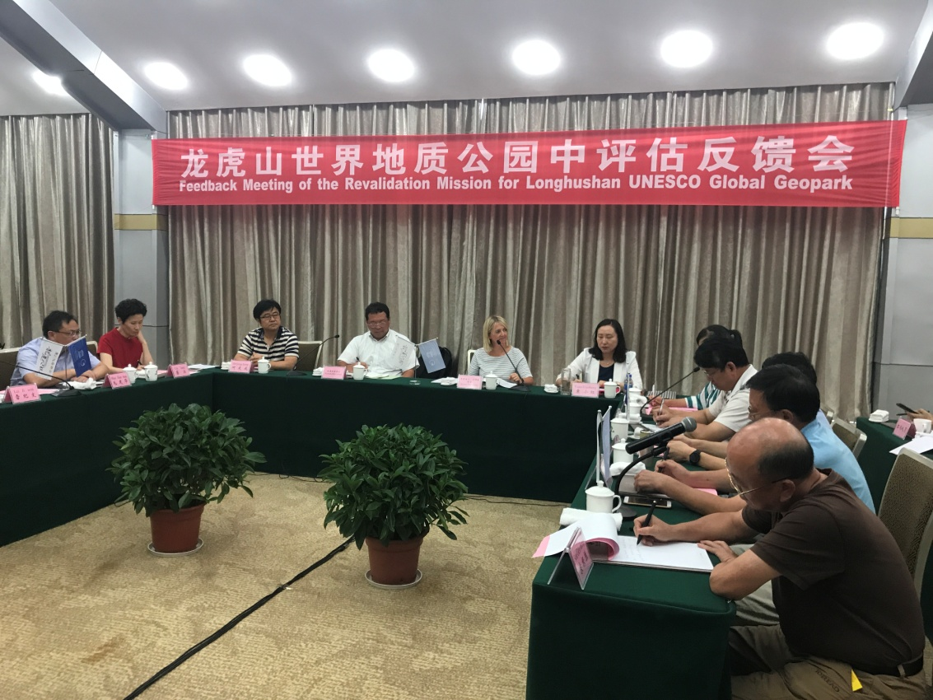
Revalidation Photo

2. GEOPARK FIGURES
Number of Geopark staffs: 845 staffs including 4 geoscientist(s)
Number of Visitors: 23.0173 million tourists
Number of Geopark events: 7
⑴2018 UNESCO Global Geopark revalidation
⑵Longhushan International Tourist Culture Festival
⑶Series activities such as popularization of geological science and the classic book of Taoism , Dao Te Jing in school, and little tour guide training
⑷Prize-giving quiz about Longhushan UNESCO Global Geopark, cooperated with Jiangxi Radio and Television Station
⑸2018 Longhushan Food Festival
⑹Longhushan Photo Contest
⑺Earth Day celebration activities
Number school classes realize Geopark educational programmes; 8
Number of Geopark press release: 6

3. GEOPARK ACTIVITIES
Major achievements in 2018
⑴Received 23.0173 million tourists with tourism income reached 83.284.68 million yuan
⑵Fulfill the mission of 2018 UNESCO Global Geopark revalidation
⑶The smart parking project of narrowband Internet of Things (NB-IoT) and the innovative product "smart bamboo raft" project, first of its kind in China have been completed and operated. Free WIFI and face recognition full coverage in park.
Contribution towards GGN - Networking and Participation
⑴Attended 2018 Annual conference of China UNESCO Global Geoparks
⑵Attended the 8th International Conference on UNESCO Global Geoparks
Management and Financial status
The management structure of the park has been continuously improved, with a sound financial condition. Tourism revenue has reached 8328.4468 million yuan.
Geoconservation
⑴Started the revision of Longhushan World Geopark Plan(2017-2030)
⑵Completed the design and construction of boundary piles in the whole area of the park.
⑶Completed the installation of logo signs and propaganda boards for geological popularization in the park
Sustainable tourism (Geotourism)
⑴Regular training for tour guides and tourism practitioners
⑵Started the image improving projects in the park, including towns, roads and river banks.
⑶Promote the construction of the park as the "Chinese Taoist Capital" and increase the awareness of Taoist culture
New Education programmes on geoconservation, sustainable development and disaster risk reduction
⑴Improved the environmental management system of the park, and constructed a good natural ecological environment.
⑵Accelerated the construction of new countryside in the park and the pilot reform of residential land.
⑶Measures for disaster prevention and reduction such as flood control, forest fire prevention, pest control and geological hazard prevention have been implemented to ensure the stability of the natural ecological environment in the park.
Strategic Partnership
⑴Established a strategic cooperation relationship with CCTV, Jiangxi TV and other media outlets
⑵Established a long-term cooperative partnership with Huashan Geopark in Shaanxi Province and Jiuhuashan Geopark in Anhui Province
⑶Established strategic partnerships with Flora World, Huaqian Town and other 24 tourism enterprises
Promotional activities
Advertising the brand image of the park in CCTV morning news. The picture of the park were putting on the main roads of the Jiangxi Province, where the park located. Publicity at the waiting platform of high-speed railway in East China. Cooperating with JXTV City Channel, we produced feature programme, Golden Week Carnival, during the Mid-Autumn Festival and the National Day Golden Week. Take part in 2018 Longhushan-Pavilion of Prince Teng summer tourist product launches.

4. Contacts:
Manager: Lei Jiwen ytslhsgtj@163.com
Scientific Responsible (Geologist): Guo Fusheng

